- EXERCISE

Watch the film here

- The film In God We Trust, directed by Mihajlo Al Popovic, was made in 1932 and is considered the most successful pre-war feature film made in Yugoslavia. The story of the film begins with a rural idyll, which lasts until the beginning of the first great world war. Two stories continue to develop in parallel: one follows a young soldier, his warfare and withdrawal from the homeland, and the other the fate of a family under occupation. When the soldier returns home, he finds only his son, who didn't even remember him…

- Based on the watched film, describe in a few sentences the importance of films dealing with significant historical events of a country.

- The pictures show the wife and father of the young soldier at the time his letter arrives:

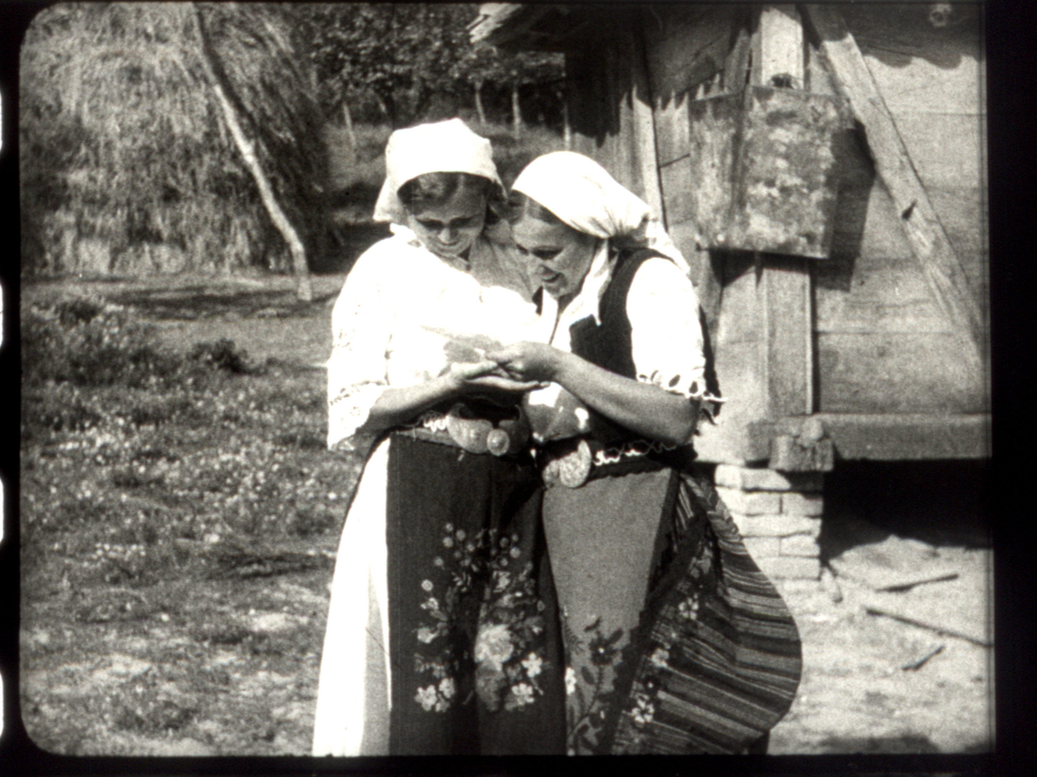
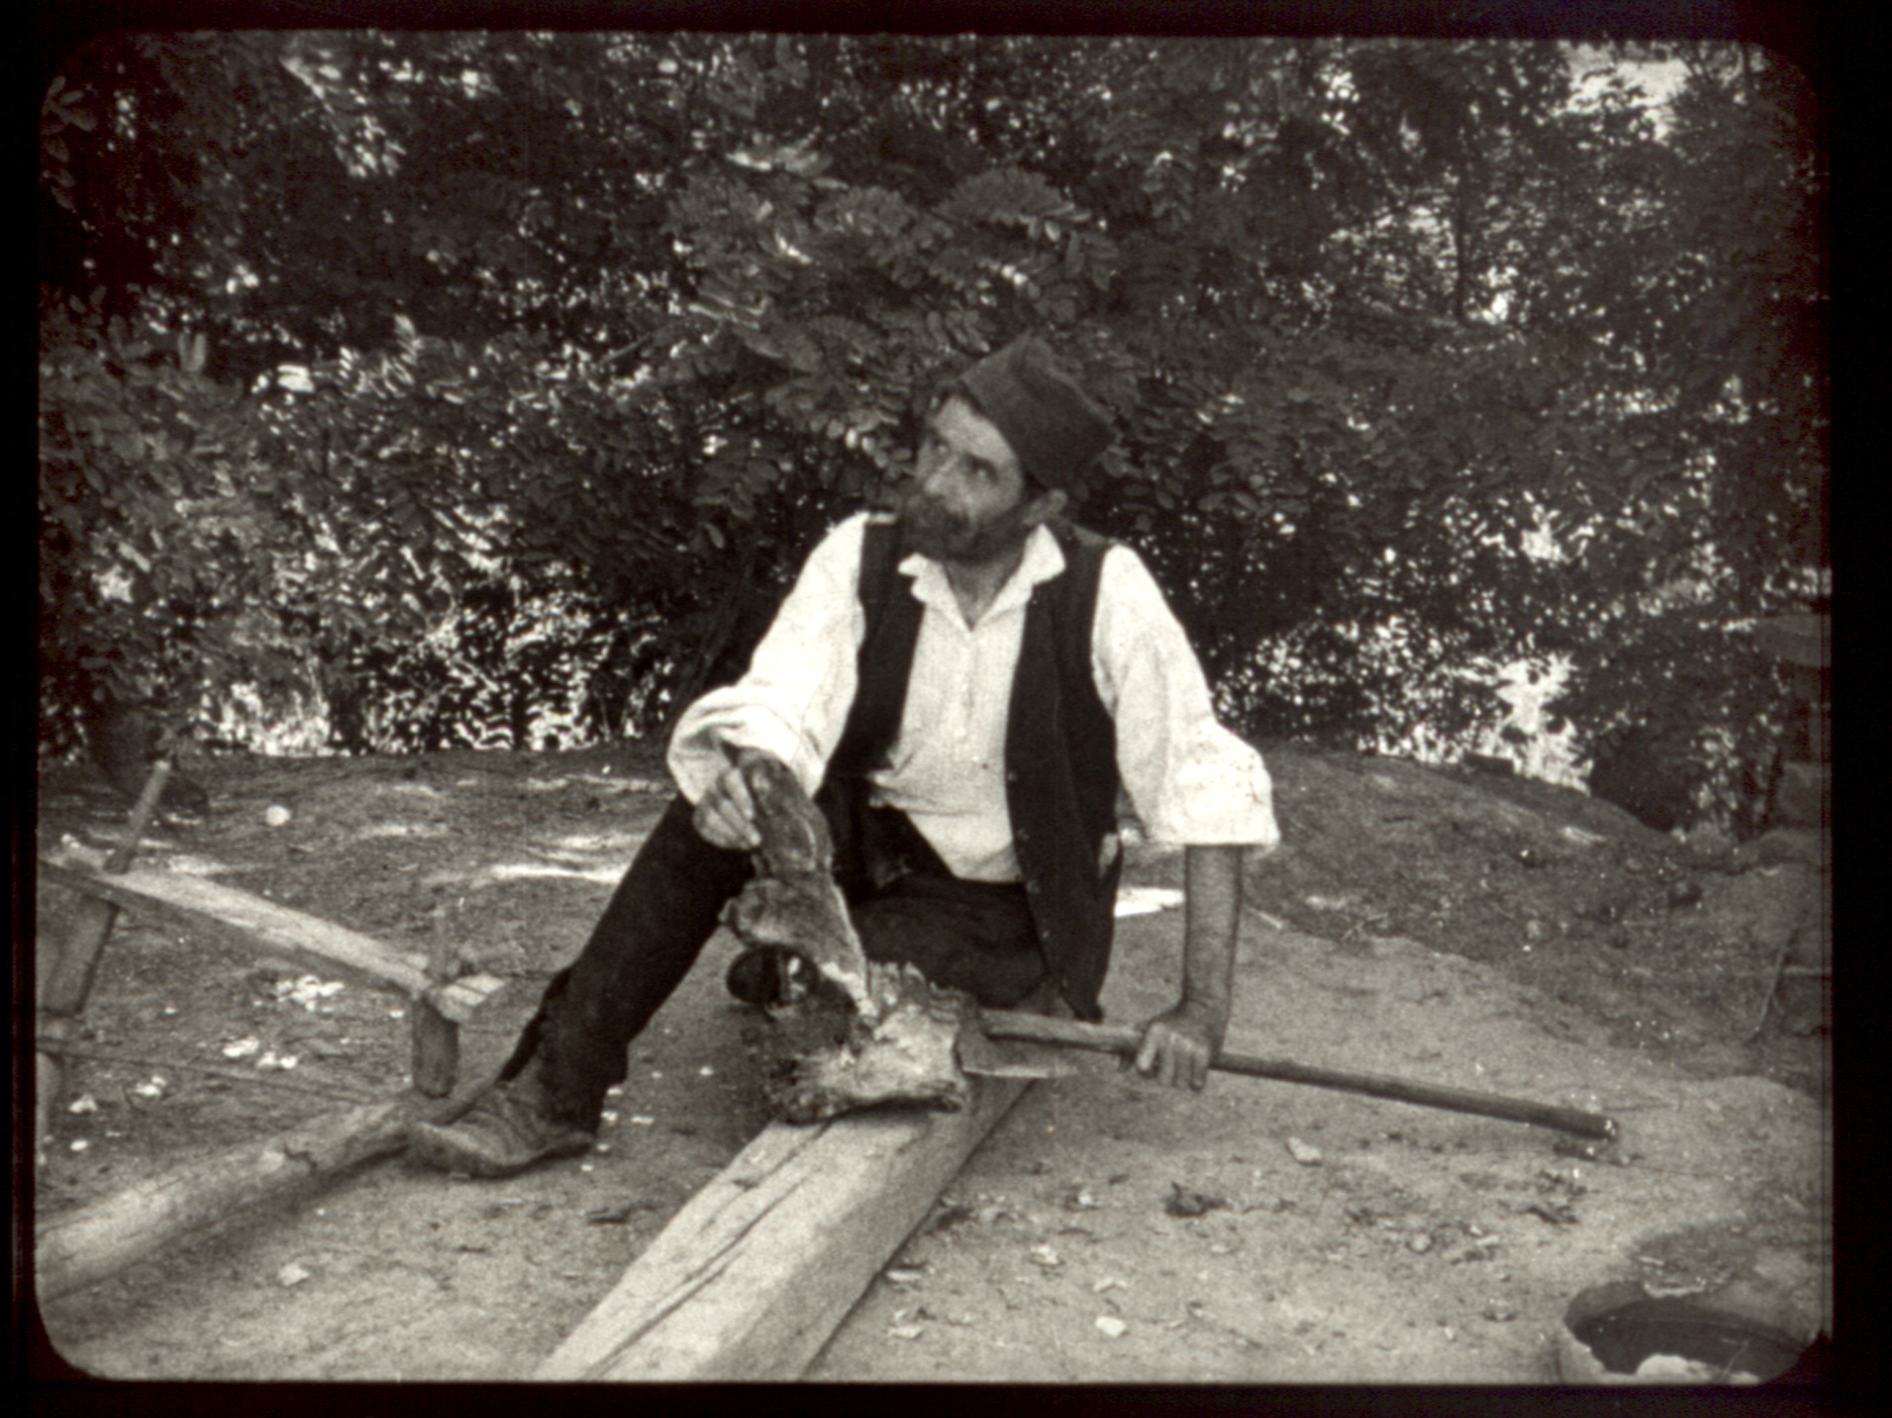

- Describe the difference in their expression of emotion
- How the director strikes a balance between experience and youthful enthusiasm

- Po povratku iz rata, mladi vojnik susreće svog sina koji ga ne prepoznaje...
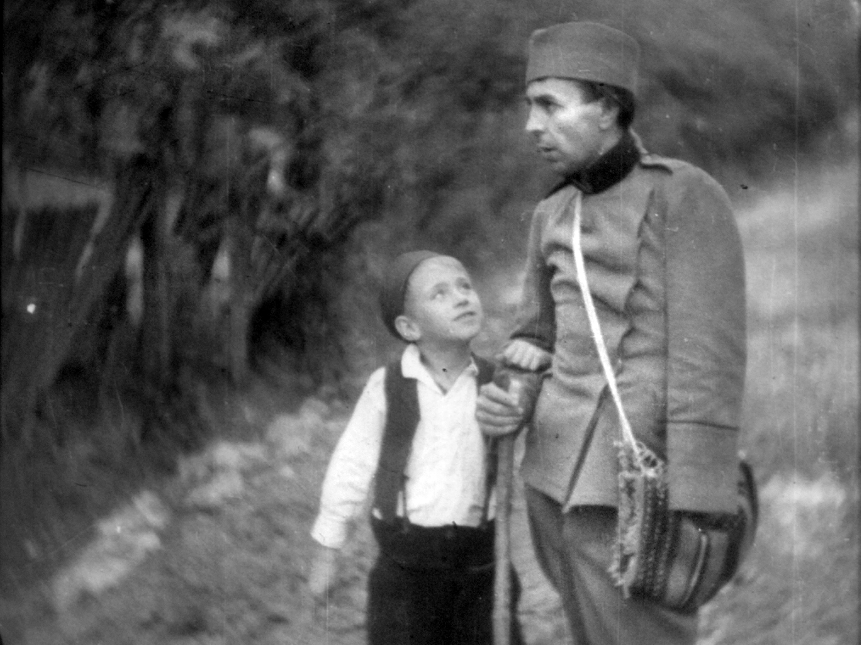
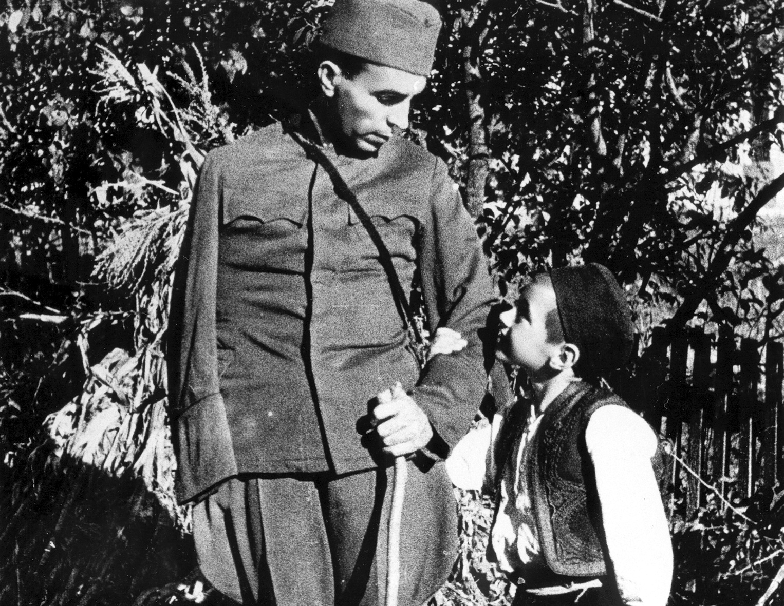

- Describe the feelings that these shots from the film produce in you
- Do you still see hope for a happier tomorrow at the end of the film?

- FUN FACTS

- Mihajlo Al. Popovic (1908-1990), one of the pioneers of film in this area, wrote a screenplay inspired by Branislav Nusic's story "The Empty House", but also by the scene of a war invalid with a medal begging in the street.
- At the time of the domination of sound, In God We Trust was made as a silent film, due to lack of funds, , but it was sounded from gramophone records, mostly with music by prominent domestic authors.

